**27/09/2021 ML LAB 4 2019103573**

**IMPLEMENT THE FOLLOWING USING PYTHON**

**DATA SETS :-**

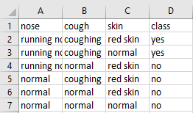**Finds.csv**

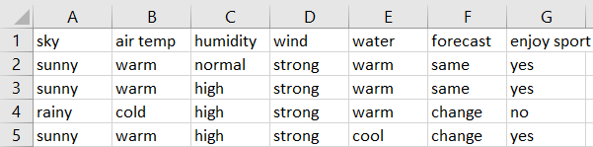**health.csv**

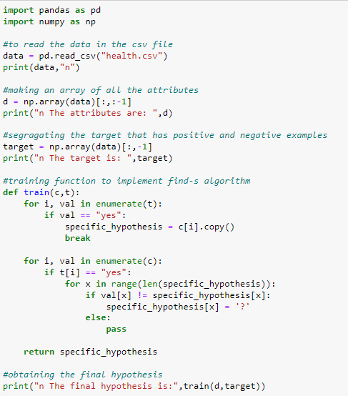**FIND S ALGORITHM**

**OUTPUT :-**

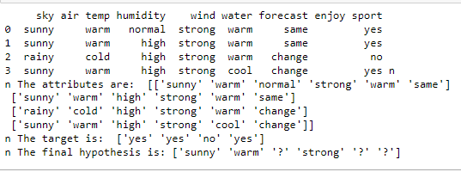**finds.csv**

**health.csv**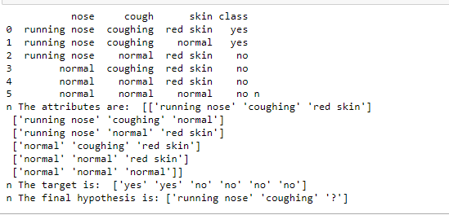

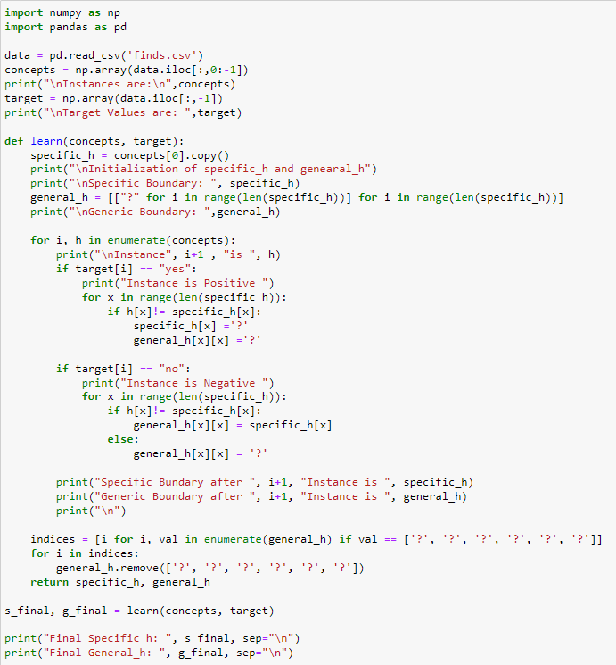**CANDIDATE ELIMINATION ALGORITHM**

**OUTPUT :-**

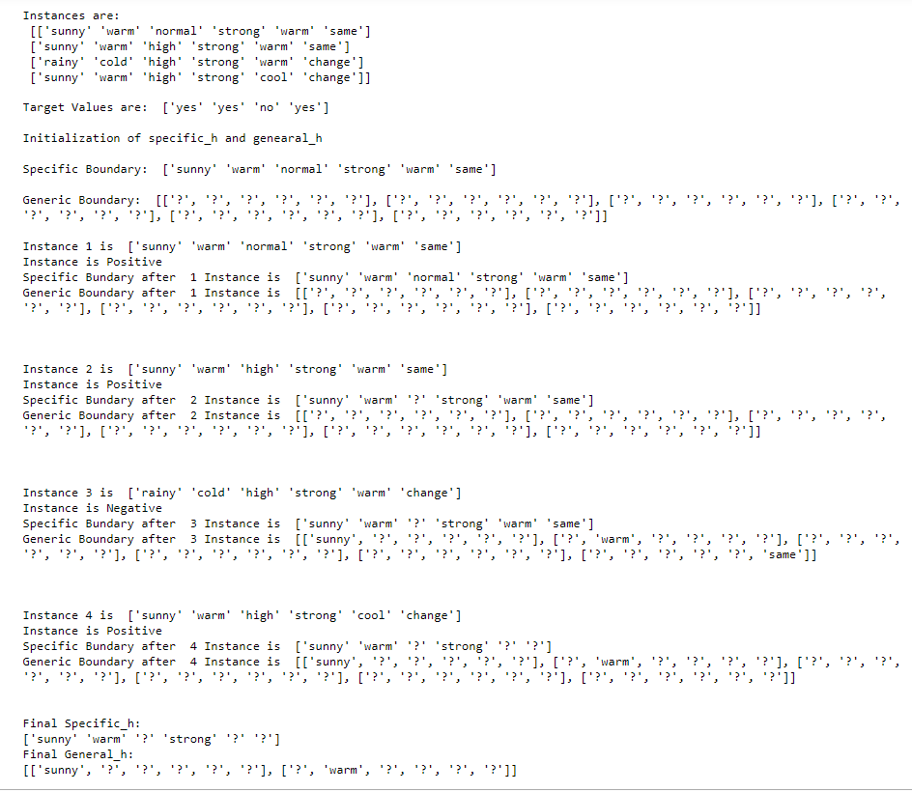**finds.csv**

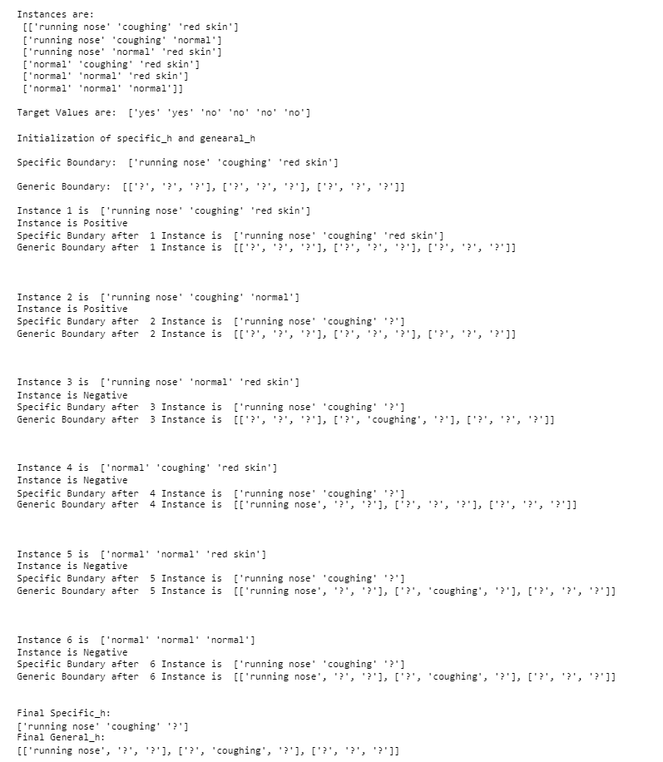**health.csv**